Lancaster Emergency Associates celebrates 50 years (Photo gallery)
September 09, 2016
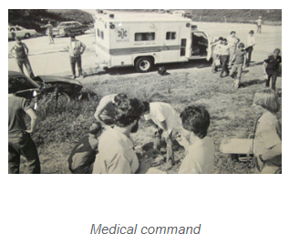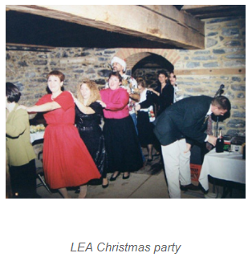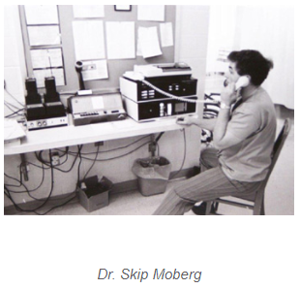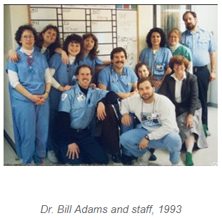
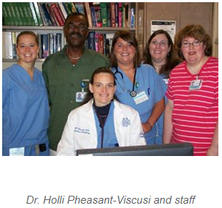

Don Berkow, M.D., used to get at least a few hours of sleep during an overnight shift in the LGH Emergency Department.
“When I first came, in 1986, I used to get sleep with no problem,” he said. “Now we can get 10 patients in an hour, even in the middle of the night. We’re wide awake now.”
Dr. Berkow is president of Lancaster Emergency Associates, which celebrates its 50th anniversary this year. His sleep schedule isn’t the only thing that’s changed in his 30 years on the job. He’s also seen significant growth in his practice, patient volume and technology, as well as two ED overhauls.
LEA is one of the oldest private emergency practices in the nation. In Dr. Berkow’s first year, LGH’s ED treated 35,000 patients. By 2015, that number more than tripled to 117,000.
“As medicine has evolved, we’ve also evolved,” he said. “The hospital grew, and we grew along with it. We are successful thanks to the commitment of the hospital.”
In 1966, former family practitioners Drs. Milton W. Johns, Robert E. Stoner, Donald D. Dunkle and F. Barry Moberg -- who had no specialty training in emergency medicine -- began staffing the LGH emergency ward on a 24-hour basis, establishing LEA.
At the time, the ER was located in the basement of the Lime Street building and used only for treating accident victims and rendering first aid. Patients paid $5 for the ER and $5 for the doctor. In 1969, the ER moved to the new North Wing, increasing in size by 50 percent.
Donna Enck, RN, BSN, ED Informatics Liaison, joined the department in 1980, when nurses rode along on ambulance calls. At the time, about five nurses worked days and evenings, and three worked nights.
“I remember coming back from an ambulance call and having to write up the ‘trip sheet,’ or account of the patient during the call,” she said. “If the ER was busy, we saw patients instead, and the trip sheet waited. Sometimes we would have three or four trip sheets to write at the end of our shift.”
Dr. Berkow joined the group in 1986, the same year LGH became a Level 2 trauma center. He was the LEA’s first residency-trained emergency physician; now all physicians in the group are specialty-trained.
In 1992, the hospital opened a newly expanded and renovated ED, including trauma bays, a chest pain emergency unit, “fast care” for minor injuries and a separate entrance for ambulance use. Another renovation followed in 2004.
Today the ED has 51 beds, and LEA has grown to 22 physicians and 13 advanced practice providers. There are now 21 nurses working days, 24 on evenings and 20 on nights.
The main ED treats about 55 percent of patients, with fast care handling the remaining 45 percent. Dr. Berkow said the area’s growing number of Urgent Care practices has helped keep volume manageable.
“The ED will always be the last line of defense for social issues, such as overdoses, mental-health concerns and people who don’t take care of themselves,” he said. “We’re a picture of society. That’s the way I would look at it.”
The ED staff works closely with specialists throughout the hospital, including trauma, cardiology, neurology and hospitalists, as well as ancillary service providers. The team now has the resources and training to handle treatments that used to require specialty care.
“Our ED serves over 117,000 patients annually because of the quality care we provide and our exceptional physicians,” said Carla Leed, Administrative Director of Trauma and Emergency Services.
Dr. Berkow most enjoys the nonstop nature of his work, despite the lack of sleep.
“I like the ability to quickly connect with patients,” he said. “I like that challenge. I feel like I’ve accomplished something. At the same time, we have to have more humility than some other specialties, because we don’t always find the answer.”

